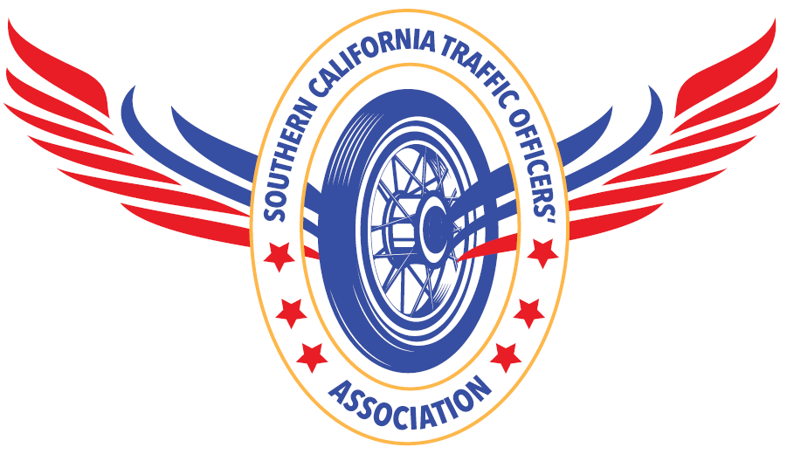
Southern California Traffic Officers’ Association

2024 Spring Police Motorcycle Training

PARTICIPANT LIABILITY WAIVER

Name Agency Telephone ( )

E-Mail

Year/Make/Model of Motor Years of Motor Officer Experience

Participant Agreement

Participant agrees to hold the Southern California Traffic Officers’ Association, its board of directors and member agencies, The County of Orange, The Orange County Sheriff’s Department, The City of Costa Mesa and their officers, agents or employees blameless, and to reimburse for any judgments, settlements, costs or other expenses (including legal fees) to which they may be subject for any injury, damage, loss or harm resulting from or occurring to anyone (including visitors) which may result directly from or in connection with such participation.

Neither the Southern California Traffic Officers’ Association, its board of directors and member agencies, The County of Orange, The Orange County Sheriff’s Department, The City of Costa Mesa and their officers, agents or employees will be responsible for any injury, loss, or damage that may arise to a participant or motorcycle.

The Southern California Traffic Officers’ Association reserves the right to restrict participants who become objectionable because of method of operation or in any way distract from the general character of the S.O.C.T.O.A.

Participants shall not injure or deface any items. If damage occurs, the participant is liable to the owner of the property damaged.

Participants shall follow the direction of all event safety officers and conduct themselves in a professional manner by operating their motorcycle in a safe and competent manner, which includes the use of a D.O.T. approved helmet, gloves and eye protection at all times.

I have read the above and will comply with the terms and conditions for participants at this event.

Signature Date 05/22/2024

